Week 06 – S2 PRACTICE: SQL Integration Solution
Student’s Name | Seat Sreylenn
Group | 02

Part A — Warm-ups: Build a CRUD API with Express.js + SQLite
Exercise 1 – Express + SQLite Project Setup
Goal: Scaffold a Node.js project, install Express and better-sqlite3.
Solution (package.json dependencies):
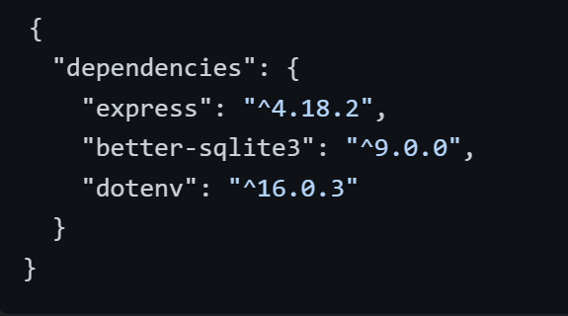
Server Entry Point (server.js):
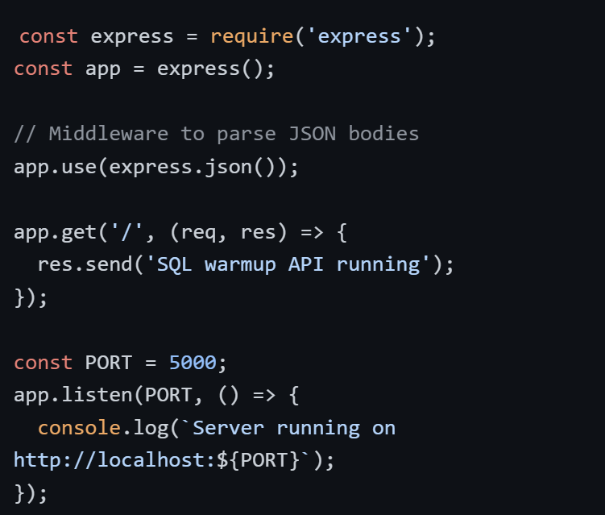

Exercise 2 – Connect my_database.db & Create the Table
Goal: Open the SQLite file and ensure the articles table exists.
Solution (utils/database.js):
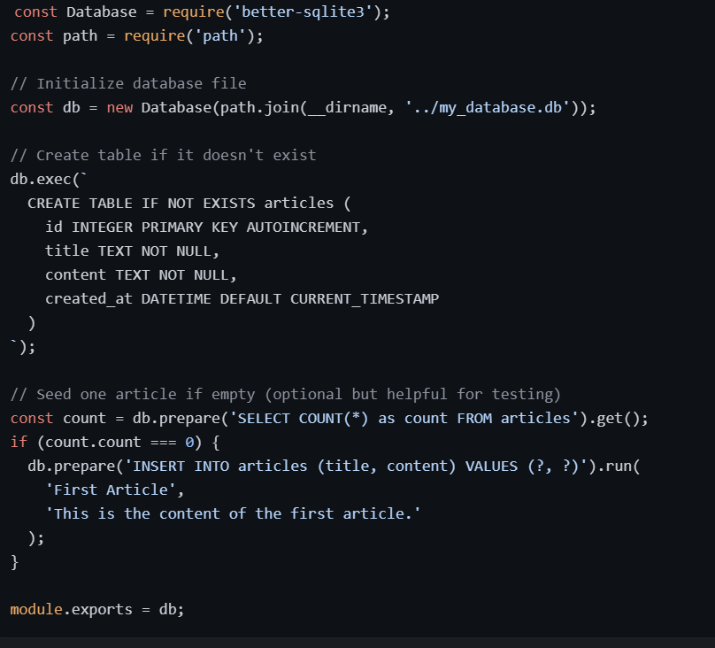
Exercise 3 – GET All Articles (Read)
Goal: Return every article as JSON.
Solution (server.js):
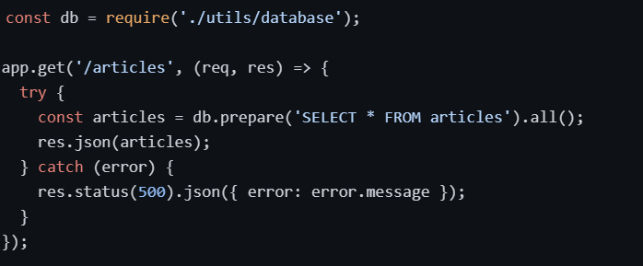
Exercise 4 – GET One Article by ID
Goal: Read a single row using a route param and parameterized query.
Solution:
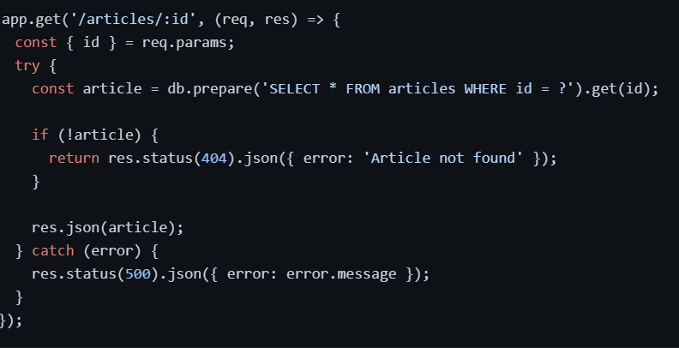
Reflection: Why use <?> placeholders?
Using ? placeholders prevents SQL Injection attacks. If you build strings with ${id}, a malicious user could input code like 1; DROP TABLE articles;. The placeholder treats the input as data, not as executable SQL code.
Exercise 5 – POST: Create an Article
Goal: Read JSON body, INSERT a new row, return created article.
Solution:
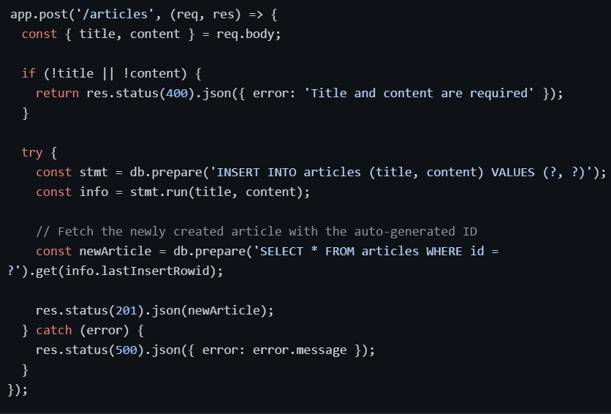
Exercise 6 – PUT: Update an Article
Goal: Update an existing row by ID.
Solution:
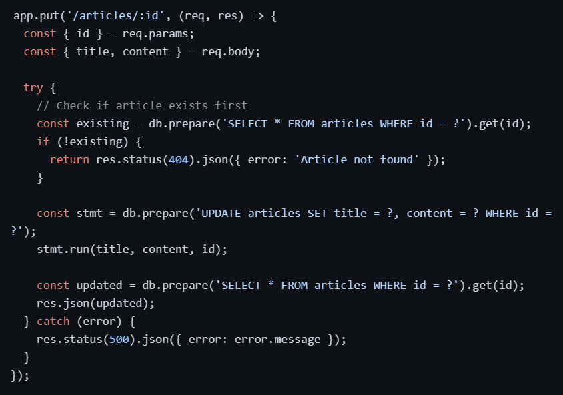
Warning: Always include WHERE id = ?. Without it, the query updates every row in the table.
Exercise 7 – DELETE an Article
Goal: Remove a row and return correct status codes.
Solution:
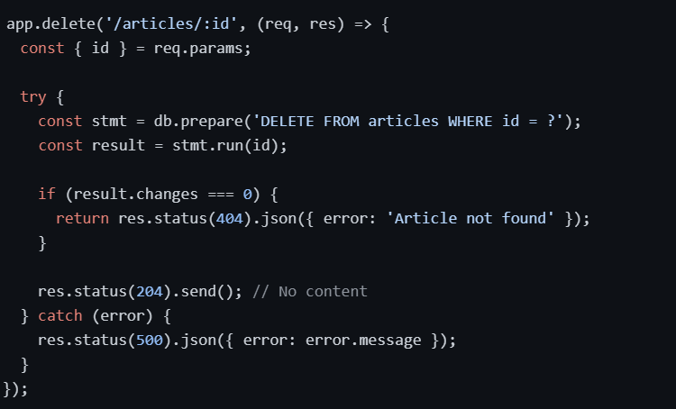
Exercise 8 – Refactor into a Repository
Goal: Move SQL out of server.js into a repository module.
Repository Structure (repositories/articleRepository.js):

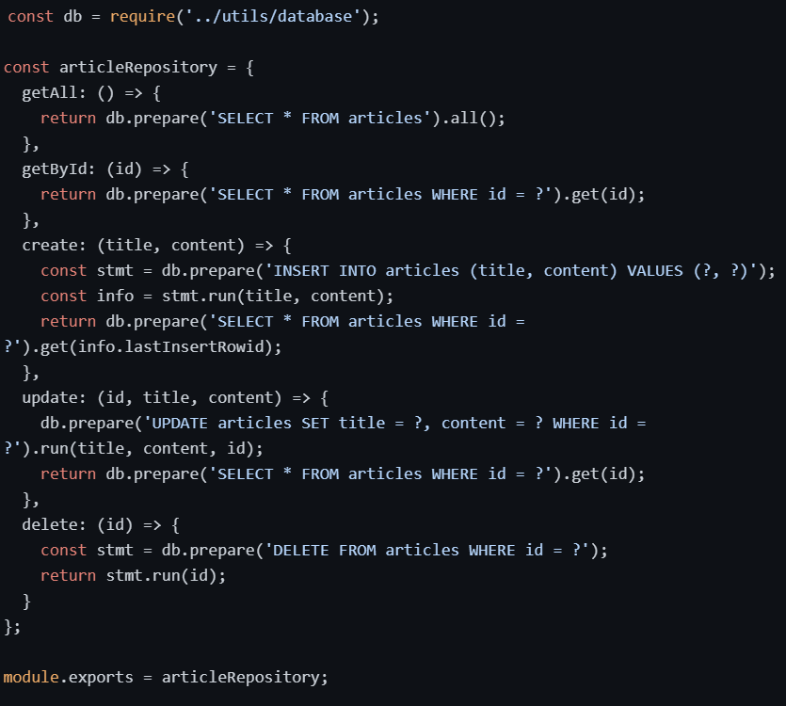
Updated server.js:
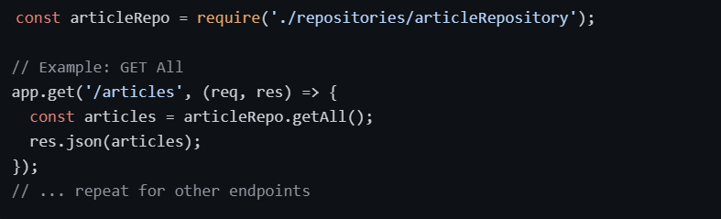
Part B — Core: SQL Integration with MySQL
Exercise 9 – MySQL Manipulation
Q1 – Create the database and the articles table
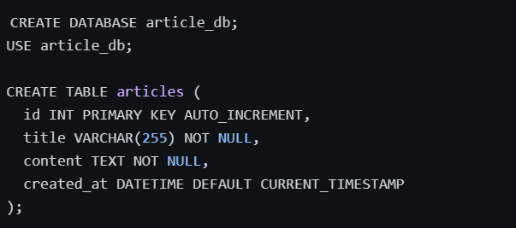
Q2 – Review MySQL queries

Operation | SQLite Syntax | MySQL Syntax
Create | INSERT INTO ... VALUES (?, ?) | INSERT INTO ... VALUES (?, ?)
Read All | SELECT * FROM articles | SELECT * FROM articles
Read One | SELECT * FROM articles WHERE id = ? | SELECT * FROM articles WHERE id = ?
Update | UPDATE articles SET ... WHERE id = ? | UPDATE articles SET ... WHERE id = ?
Delete | DELETE FROM articles WHERE id = ? | DELETE FROM articles WHERE id = ?

Exercise 10 – MySQL on the Backend
Q4 – Why 3 layers? (Responsibilities)

Layer | Responsibility
Routes | Define API endpoints (URLs) and HTTP methods (GET, POST, etc.). They receive requests and pass data to controllers.
Controllers | Handle business logic. They parse request data, call the repository, and format the response (status codes, JSON).
Repository | Handles direct database interaction. It contains all SQL queries and abstracts the database driver from the rest of the app.

Q5 – Implement the database connection
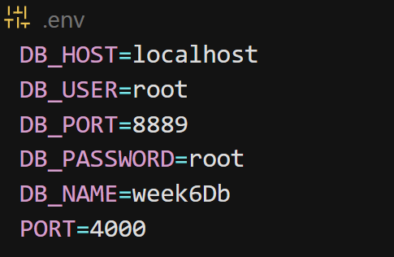

2. utils/database.js (Connection Pool):
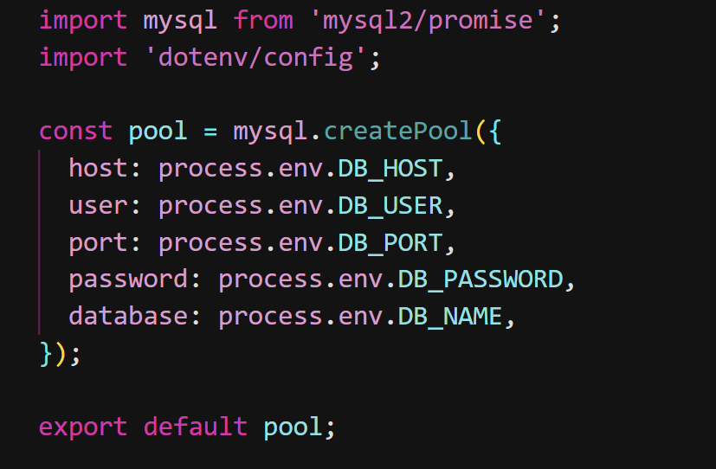
3. repository/sqlArticleRepository.js (Async Implementation):
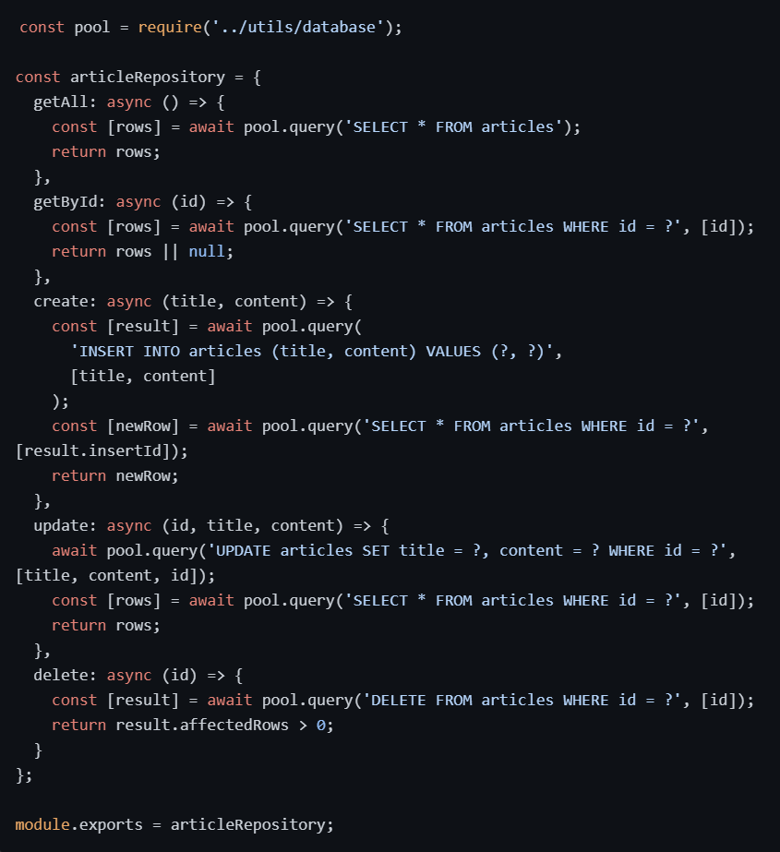
Exercise 11 – Handle Journalists
Database Update:

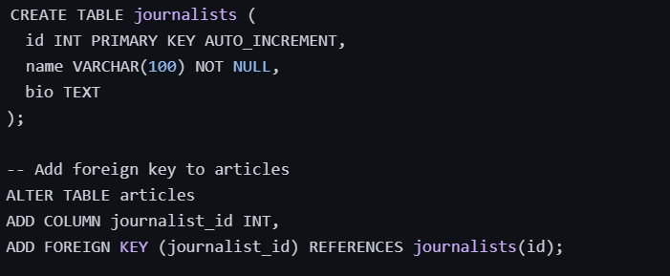
Back End Changes:
- Create journalistRepository similar to articleRepository.
- Update articleRepository to join journalists:

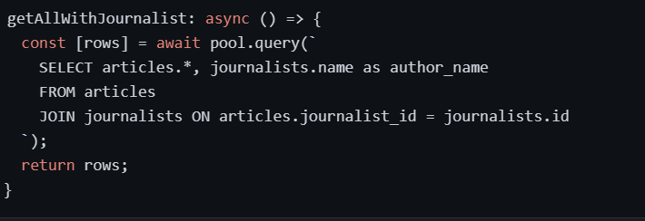
Front End Changes:
- Create a JournalistList component.
- Add a dropdown or filter to ArticleList to filter by journalist_id.

Exercise 12 – Handle Tags (Bonus)
Database Update (Many-to-Many):
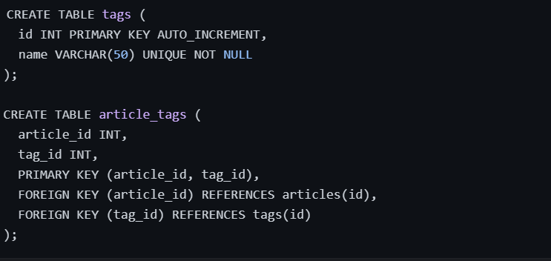
Back End:
- Implement getArticlesByTag(tagName) which joins articles, article_tags, and tags.
Front End:
- Add a tag selector (checkboxes or dropdown) to filter the article list.

Reflective Questions Summary
1. How does a SQL JOIN help you combine articles with journalists or categories?
A SQL JOIN allows you to retrieve related data from multiple tables in a single database query. Instead of making separate requests to the database and stitching the results together later, a JOIN matches rows based on a common column (like journalist_id in the articles table matching the id in the journalists table).
Comparison: JOIN vs. Fetching Separately
- Using JOIN: You send one query (e.g., SELECT * FROM articles JOIN journalists ON ...). The database does the heavy lifting of matching and merging. This is faster (fewer network round-trips to the DB) and ensures data consistency at the source.
- Fetching Separately: You would need to:
  - Fetch all articles.
  - Fetch all journalists.
  - Write JavaScript code to loop through the articles and attach the matching journalist object to each one. This approach is slower (multiple queries), uses more memory (loading two full tables into JS), and increases the risk of logic errors if the matching logic in JavaScript is imperfect.
2. What kind of relationship exists between articles and categories, and how does it differ from the articles–journalist relationship?
Answer: The relationships differ in cardinality, which dictates how the database schema is designed:
- Articles – Journalist (One-to-Many):
  - Relationship: One journalist can write many articles, but one article is written by only one journalist.
  - Schema: This is implemented by adding a journalist_id column (Foreign Key) directly into the articles table.
- Articles – Categories (Many-to-Many):
  - Relationship: One article can have multiple tags/categories, and one category can apply to many articles.
  - Schema: You cannot store this in just one of the existing tables. You need a junction table (e.g., article_tags or article_categories) that contains two foreign keys: article_id and category_id. This allows multiple rows for the same article with different category IDs.
3. Why is the repository layer a good place to keep all SQL queries?

Answer:
The repository layer acts as a single source of truth for data access logic, enforcing the Separation of Concerns principle.
- Maintainability: If you need to change a query (e.g., adding a new column or changing a filter), you only update it in one file (sqlArticleRepository.js) rather than searching through every controller or route handler.
- Testability: You can unit test your SQL logic independently from your API logic.
- Consistency: It ensures that all data access follows the same patterns (like error handling and parameter usage).
Warm-up vs. MySQL Repository: As observed in Exercises 8 and 10, the shape of the repository remains identical regardless of the database engine.
- SQLite: Uses better-sqlite3 (synchronous or specific driver methods).
- MySQL: Uses mysql2 with pool.query (asynchronous). The logic (SELECT, INSERT, WHERE clauses) stays the same; only the driver method changes. This proves that the repository layer successfully abstracts the database implementation details from the rest of the application.
4. How do parameterised queries (? placeholders) protect your app, and where did you use them?

Answer: Protection Mechanism: Parameterised queries prevent SQL Injection attacks.
- Without them: If you build a query string like SELECT * FROM users WHERE id = ${userInput}, a malicious user could input 1 OR 1=1 to bypass authentication or delete data.
- With them: The database treats the input strictly as data, not as executable code. The ? placeholder ensures that even if a user submits malicious SQL syntax, it is escaped and treated as a literal string value.
Where they were used: You used them in every CRUD operation in both the SQLite and MySQL exercises:
- GET by ID: SELECT * FROM articles WHERE id = ?
- POST: INSERT INTO articles (title, content, ...) VALUES (?, ?, ...)
- PUT: UPDATE articles SET title = ? WHERE id = ?
- DELETE: DELETE FROM articles WHERE id = ?
By consistently using ? and passing the values as an array (e.g., [id] or [title, content]), you ensured the application remains secure against injection attempts.

